**WEB DESIGNING AT ARICENT**

An Industrial Internship Report

*submitted by*

**AKSHAY ARORA**

**16BCE0944**

*in partial fulfillment for the award of the degree of*

**B. TECH**

in

**COMPUTER SCIENCE**







**SCHOOL OF COMPUTER SCIENCE AND ENGINEERING**

AUGUST 2018

**DECLARATION BY THE CANDIDATE**

I hereby declare that the Industrial Internship report entitled “**WEB DESIGNING AT ARICENT”** submitted by me to Vellore Institute of Technology, Vellore in partial fulfillment of the requirement for the award of the degree of **B. TECH** in **CSE** is a record of bonafide industrial training undertaken by me under the supervision of **Ms. Prerna Garg, Aricent Technologies.** I further declare that the work reported in this report has not been submitted and will not be submitted, either in part or in full, for the award of any other degree or diploma in this institute or any other institute or university.

Name: Akshay Arora

Reg. Number: 16BCE0944



**School of Computer Science and Engineering**

**BONAFIDE CERTIFICATE**

This is to certify that the Industrial Internship report entitled “**WEB DESIGNING AT ARICENT”** submitted by **AKSHAY ARORA (16BCE0944)** to Vellore Institute of Technology, Vellore in partial fulfillment of the requirement for the award of the degree of **B. TECH** in **COMPUTER SCIENCE** is a record of bonafide Industrial Internship undertaken by him/her under my supervision. The training fulfills the requirements as per the regulations of this Institute and in my opinion meets the necessary standards for submission. The contents of this report have not been submitted and will not be submitted either in part or in full, for the award of any other degree or diploma in this institute or any other institute or university.

Signature of the Supervisor

Date: Date:

**Internal Examiner (s) External Examiner (s)**



**ACKNOWLEDGEMENT**

This report has been prepared for the internship that has been done in the Aricent Technologies (Holding) Ltd., Gurugram in order to study the practical aspect of the course and implementation of the theory in the real field with the purpose of fulfilling the requirements of the course of B.Tech in CSE. The aim of this internship is to be familiar to the practical aspect and uses of theoretical knowledge and clarifying the career goals, so I have successfully completed the internship and compiled this report as the summary and the conclusion that have drawn from the internship experience.

I would like to express my sincere gratitude to my internship supervisor, Ms. Prerna Garg, who has given her valuable time and given me chance to learn something despite having their busy schedule and Mr. Utkarsh Singh for his great guidelines for internship.

Lastly, I would like to thank Mr. Pratyush Dasgupta of Aricent Technologies for providing this opportunity to work in the company. Thus, the time in this company was very audacious and supportive to my career through which I have gained valuable work experience.

Place : Vellore

**Akshay Arora**

Date : 17-10-18

**TABLE OF CONTENTS**

|  |  |  |
| --- | --- | --- |
| **CHAPTER NO.** | **TITLE** | **PAGE NO.** |
|  | LIST OF TABLES | viii |
|  | LIST OF FIGURES | ix |
| 1. | SYNOPSIS OF THE REPORT | 1 |
| 2. | ABOUT ARICENT | 2 |
|  | 2.1 INTRODUCTION | 2 |
|  | 2.2 HISTORY | 2 |
|  | 2.3 SERVICES | 4 |
|  | 2.3.1 Digital Design Services | 4 |
|  | 2.3.2 Software Product Development | 4 |
|  | 2.3.3Systems and Silicon Development | 5 |
|  | 2.3.4 Testing Services | 5 |
|  | 2.3.5 Product Sustenance and Maintenance | 5 |
|  | 2.4 Tools and Framework | 5 |
| 3 | PREVIOUSLY ACQUIRED KNOWLEDGE | 7 |
|  | 3.1 BASIC HTML | 7 |
|  | 3.2 SQL | 7 |
|  | 3.3 BASIC ANDROID APP DEVELOPMENT | 7 |
|  | 3.3.1 Additional Components | 9 |
|  | 3.4 SOME CODING LANGUAGES | 10 |
|  | 3.5 PHOTOSHOP | 10 |
| 4 | KNOWLEDGE ACQUIRED | 11 |
|  | 4.1 Advanced HTML | 11 |
|  | 4.2 Style Sheets | 12 |
|  | 4.2.1 CSS | 12 |
|  | 4.2.2 SASS | 13 |
|  | 4.2.3 SCSS | 13 |
|  | 4.2.4 LESS | 13 |
|  | 4.2.5 CSS BOX MODEL | 13 |
|  | 4.3 Web design Techniques | 14 |
|  | 4.3.1 Responsive Web design | 14 |
|  | 4.3.2 Browser Dev Tools | 15 |
|  | 4.4 Software Development Activities | 15 |
|  | 4.4.1 SCRUM | 16 |
|  | 4.5 JavaScript | 17 |
|  | 4.5.1 jQuery | 17 |
|  | 4.5.2 Bootstrap | 18 |
|  | 4.6 Angular | 18 |
|  | 4.6.1 Architecture overview | 19 |
|  | 4.6.2 Components | 19 |
|  | 4.6.3 jQuery | 19 |
|  | 4.6.4 Routing | 19 |
|  | 4.6.5 PIPES | 20 |
|  | 4.7 Node js and Npm | 20 |
|  | 4.8 Google Maps Integration | 20 |
|  | 4.8.1 Localization | 21 |
|  | 4.8.2 Versioning | 21 |
|  | 4.8.3 Basic Map Types | 21 |
|  | 4.8.4 Layers | 21 |
| 5 | APPLICATION IN TRAINING | 22 |
|  | 5.1 Startup Company Website Homepage | 22 |
|  | 5.2 Google Map Integration Using Angular | 25 |
| 6 | SELF-EVALUATION | 30 |
|  | 6.1 Evaluating Myself | 30 |
|  | 6.2 Internship Benefits | 30 |
|  | 6.3 Conclusion | 31 |
|  | APPENDIX-1 | 32 |
|  | APPENDIX-2 | 35 |

**LIST OF TABLES**

Table 1: History of Aricent Page No. – 2

Table 2: Additional Components of Android Page No. – 11

Table 3: Some Special Characters Page No. – 13

**LIST OF FIGURES**

Figure 1: Aricent Company Logo Page No. – 2

Figure 2: Android Framework Page No. – 10

Figure 3: CSS Box Model Page No. – 15

Figure 4: Scrum Model Page No. – 17

Figure 5: Data Flow of Scrum Model Page No. – 18

Figure 6: Starting view of website Page No. – 23

Figure 7: Section using grid Page No. – 24

Figure 8: A simple step method with two grid section Page No. – 25

Figure 9: Packages description of the website Page No. – 26

Figure 10: Dashboard of Angular website Page No. – 27

Figure 11: Details page of any place Page No. – 28

Figure 12: List showing all the places Page No. – 29

Figure 13: Ability to add or delete places Page No. – 29

Figure 14: Map Integrated in Angular Page No. – 30

Figure 15: Place Search in maps Page No. – 30

**Chapter 1**

**SYNOPSIS OF THE REPORT**

This internship report is on Web Design at Aricent Technologies.

This report is divided into six chapters. The first chapter of this study deals with synopsis of this report, the second chapter of this report is about Aricent Technologies, their history, the services they provide and the tools and framework they use. The third chapter is about the previous knowledge I have acquired through the curriculum of the college or from my school or from personal interests which have been useful in the web design industry. The fourth chapter is all about the new knowledge I have gained from this internship. It includes all the tools, languages and software’s I undertook and learnt in this internship month. The fifth chapter is about the applications of the knowledge I gained throughout the internship. It involves me understanding JavaScript and designing a website and also taking a project on angular for map integration. The sixth chapter is about conclusions and recommendations which are drawn by analysis of whole study.

During my internship at Aricent I was able to experience work in a web design department of the Company. Since I have had some experience with designing and my interest in software, my boss assigned me to all these new things from the web developing department.

**Chapter 2**

**ABOUT ARICENT**



Figure 1: Aricent Company Logo

**2.1 Introduction**

Aricent is a global design and engineering company innovating for customers in the digital era. They help their clients lead into the future by solving their most complex and mission critical issues through customized solutions. For decades, they have been helping companies do new things and scale with intention. They bring differentiated value and capability in focused industries to help transform products, brands and companies.

Aricent also takes pride in partnering with the world’s leading technology brands. Together they are responsible for innovations that have created new markets worth billions. Working with Aricent means having a highly skilled leadership team that’s focused on your projects and understands how to create a framework for consistent innovation. They are the expertise behind many of the technologies that are powering a fully connected world. They are very proud to say that 90% of Aricent’s engineering leadership has been with the company for 10 years or more.

**2.2 History**

|  |  |
| --- | --- |
| **Year** | **Major Development** |
| 1991 | Started operations as captive for Hughes Network Systems. Built software for the six largest satellite networks deployed globally. |
| 1992 | Deployed world’s first frame relay network across marquee clients, and worked in cutting-edge cellular technologies. |
| 1996 | Expanded business to non-Hughes clients based on our highly regarded telecom competency. Quickly became market leaders for SS7 signaling and Voice over IP. |
| 1997 | Went public in India as the first highly successful book-building IPO. |
| 1997-98 | Signed key clients like Nokia, Alcatel, NEC. Launched Intelligent Peripheral as a key node in the evolving intelligent networks market. |
| 1998-99 | Launched new software frameworks to manage telecom networks. |
| 2003 | Signed Lucent, Cisco as key clients. Opened wireless center of excellence in Nürnberg, Germany.  Acquired by Flextronics and became Flextronics Software Systems. Added wireless, wireline, testing and multimedia capabilities from several acquisitions. |
| 2004 | Launched switching & routing framework. Signed 200 leading equipment manufacturers in next five years. Signed semiconductor partnerships with Broadcom, Marvel, Fulcrum. |
| 2004-05 | Acquired Datalinx and launched service provider offerings with AT&T, Verizon and Vodafone as key clients. |
| 2006 | Taken over by Kohlberg Kravis Roberts and Sequoia Capital. Became private company and re-named Aricent, including subsidiary Frog Design. |
| 2007 | Worked with IP Access to create the world’s first Femtocell “small cell” mobile phone base station. Built world’s first WiMAX base station with Alvarion. |
| 2008 | Created world’s first in-flight Wi-Fi broadband service with Aircel.  Launched Product Support Services as a key offering, with marquee clients including Cisco. |
| 2010 | Launched enabling software for LTE networks to advance 4G deployments. Signed 70 leading LTE equipment manufacturers in next four years. Signed semiconductor partnerships with Qualcomm, Freescale, Mindspeed (Intel), Broadcom and others.  Opened engineering center of excellence for network applications. Opened center of excellence for 3G in Shenzhen, China. |
| 2010-11 | Launched dedicated practice for Semiconductor & Embedded market segment to diversify business. Signed key clients including Intel. |
| 2011 | Opened engineering and development center for testing and wireless technologies in Vietnam. |
| 2011-12 | Launched dedicated practice for Software & Internet Services market segment to diversify business. Signed key clients including Microsoft. |
| 2012 | Launched new software frameworks for the emerging software-defined networking (SDN) and OpenFlow movements. |
| 2012-13 | Aricent hires new CEO Frank Kern October’12. Expands executive team with new leadership hires. Builds operational discipline and accelerates diversification. |
| 2014 | Unveiled new software for self-optimized networks at Mobile World Congress. |
| 2015 | Acquired SmartPlay to accelerate the growth of our business in the semiconductor industry. |
| 2017 | KKR group led Aricent been acquired by France's based [Altran](https://en.wikipedia.org/wiki/Altran). |
| 2018 | [Altran](https://en.wikipedia.org/wiki/Altran) acquires Aricent |

Table 1: History of Aricent

**2.3 Services**

**2.3.1 Digital Design Services**

Digital Design Services bring together the capabilities from human–centered design to digital transformation and product realization. They are uniquely positioned to transform businesses at scale by creating systems of brand, product and service that deliver a distinctly better experience. With frog powering this design arm of Aricent, they’re able to create exceptional digital experiences that will transform any business at scale.

**2.3.2 Software Product Development**

In the Digital Era, value lies with Software. Aricent translates emerging trends into critical products and services which transform the business models, create new revenue streams and engages customers like never before.

At Aricent, they have the power to transform everything from business to your opportunities, and most importantly–your ROI. This is done by creating software and services that deliver a distinctly better experience.

**2.3.3 Systems and Silicon Development**

The services span silicon design, validation and verification of board and hardware systems to address the industry needs of the automotive, industrial equipment, consumer electronics and networking and telecommunication sectors.

From chip to platform design, they help provide services for new product development, shorten time-to-market, increase derivative portfolios and drive revenue.

**2.3.4 Testing Services**

The accelerating pace of innovation in new technologies, networks and methodologies is forcing companies to adopt new strategies to achieve a competitive edge in an ever–changing market. Today’s hypercompetitive landscape requires intelligent test solutions that can manage the higher velocity, volume and complexity of new product releases while improving product quality, lowering costs and accelerating time–to–revenue.

**2.3.5 Product Sustenance and Maintenance**

With the unique Product Transformation Services (PTS) and full scope Product Support Services Aricent help clients extend the life of core products, improving performance and amplifying market relevance, revenue potential and profitability. They develop product roadmaps that leverage new technologies and develop methodologies that allow customers to focus on investments in their new product portfolios, which are paid for by the improved financial performance of their mature products.

**2.4 Tools and Framework**

Over the years Aricent has worked with many tools and technology. Some of those are given below.

**.NET & MICROSOFT WORLD**

* WCF
* WPF
* Silverlight
* LINQ
* LINQ to SQL
* ADO.NET Entity Framework
* ASP.NET MVC
* Microsoft Enterprise Library

**PYTHON WORLD**

* Django
* South
* Celery
* Tornado

**THIRDPARTY FRAMEWORKS**

* Selenium Webdriver
* Various PDF frameworks
* Various control libraries
* OCR SDKs
* CrystalReports

**JAVA WORLD**

* JSP
* JSF
* JPA
* Hibernate
* CDI
* JAX-RS
* RESTEasy
* Spring
* Seam
* Maven

**CLOUD**

* Amazon AWS
* S3
* Rackspace
* Heroku
* Windows Azure

**DATABASE AND NOSQL**

* MS SQL Server
* MySQL
* MongoDB
* Couchbase

**JAVASCRIPT UNIVERSE**

* jQuery
* jQuery UI
* Node.js
* AngularJS
* Ext JS
* Knockout.js
* RequireJS
* jQuery Mobile

**WORLD OF WEB**

* Html 5
* CSS 2
* CSS 3
* THE XML GANG
* XSLT
* XPath
* XSL-FO

**MOBILE SPACE**

* Objective-C
* Cocoa
* Cocos2d
* Titanium
* Phonegap
* jQuery Mobile
* HTML5
* Android
* IOS
* Windows Mobile

**Chapter 3**

**PREVIOUSLY ACQUIRED KNOWLEDGE**

Here are some previously known tools, languages or technologies before I started my internship in the web design-

**3.1 BASIC HTML**

Before joining the company for a month-long internship, I only knew about basic HTML on how to make a simple webpage. I knew nothing about styling using CSS etc or any JavaScript techniques. I was able to design just a basic webpage using simple tags like <p>, <body>, <h1> to <h6>, <title>, <table> etc. Here is the use of some of these tags.

The HTML document itself begins with <html> and ends with </html>. The visible part of the HTML document is between <body> and </body>. Any document starts with a heading. You can use different sizes for your headings. HTML also has six levels of headings, which use the elements <h1>, <h2>, <h3>, <h4>, <h5> and <h6>.

**3.2 SQL**

I also knew about database management using SQL language. All the basic commands and how to create, edit and delete contents in a database. All these commands were taught in the curriculum in the previous semester in database management systems (DBMS). SQL is a programming language for Relational Databases. It is designed over relational algebra and tuple relational calculus. SQL comes as a package with all major distributions of RDBMS.

SQL comprises both data definition and data manipulation languages. Using the data definition properties of SQL, one can design and modify database schema, whereas data manipulation properties allows SQL to store and retrieve data from database.

**3.3 BASIC ANDROID APP DEVELOPMENT**

I had a knowledge about basic android app development on how to create various pages (known as activities), buttons and taking input from using and manipulating them accordingly which I got from various courses like Google Developers Group for which I had to make a weather app as a final project for the course. Also, I had designed some basic apps in my school time for competitions etc. I had also used these app development techniques for making an app in the course- Theory of Computation (TOC). Android Studio is used for developing apps for android which is provided by Google as an Open Source Software.

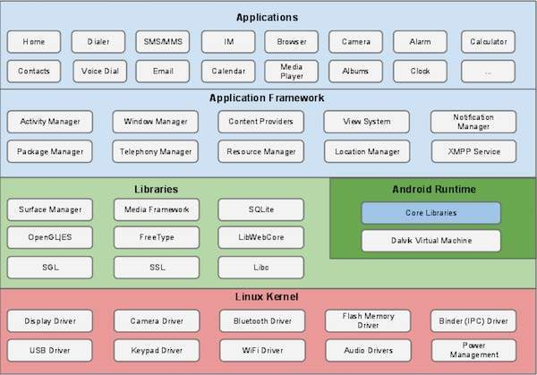

Figure 2: Android Framework

Some of the basic components I know are-

Activities

They dictate the UI and handle the user interaction to the smart phone screen.

An activity represents a single screen with a user interface, in-short Activity performs actions on the screen. For example, an email application might have one activity that shows a list of new emails, another activity to compose an email, and another activity for reading emails. If an application has more than one activity, then one of them should be marked as the activity that is presented when the application is launched.

Services

They handle background processing associated with an application.

A service is a component that runs in the background to perform long-running operations. For example, a service might play music in the background while the user is in a different application, or it might fetch data over the network without blocking user interaction with an activity.

Broadcast Receivers

They handle communication between Android OS and applications.

Broadcast Receivers simply respond to broadcast messages from other applications or from the system. For example, applications can also initiate broadcasts to let other applications know that some data has been downloaded to the device and is available for them to use, so this is broadcast receiver who will intercept this communication and will initiate appropriate action.

Content Providers

They handle data and database management issues. A content provider component supplies data from one application to others on request. Such requests are handled by the methods of the *ContentResolver*class. The data may be stored in the file system, the database or somewhere else entirely.

**3.3.1 Additional Components**

|  |  |
| --- | --- |
| **S. No** | **Components & Description** |
| 1 | **Fragments**  Represents a portion of user interface in an Activity. |
| 2 | **Views**  UI elements that are drawn on-screen including buttons, lists forms etc. |
| 3 | **Layouts**  View hierarchies that control screen format and appearance of the views. |
| 4 | **Intents**  Messages wiring components together. |
| 5 | **Resources**  External elements, such as strings, constants and drawable pictures. |
| 6 | **Manifest**  Configuration file for the application. |

Table 2: Additional Components of Android

**3.4 SOME CODING LANGUAGES**

I also knew a few coding languages like C, C++, Python etc but the most important language in the industry is python. I had learnt python in the first semester which was very useful as a base in understanding various other coding languages.

Python is one of the most widely-used high-level programming languages. This is mostly because it is simple, readable and you can use fewer lines of code to express a concept than you would have to with other languages. It is a scripting language which allows you to produce a lot of code in short periods of time.

It is opensource and free and there are a lot of tools and documentation available for learning Python. There are some great official tutorials which are easy to follow and there is less of an emphasis on syntax which would suit beginners. It is a good stepping stone for moving on and learning other object-oriented languages.

**3.5 PHOTOSHOP**

Knowledge of photoshop is very helpful in any designing industry especially web designing. It helped me design logos, icons and backgrounds to make website look aesthetically appealing. It can also help in making a basic website design as a template before starting it to actually design it.

Adobe Photoshop is the predominant photo editing and manipulation software on the market. Its uses range from the full-featured editing of large batches of photos to creating intricate digital paintings and drawings that mimic those done by hand.

It is the most widely used software tool for photo editing, image manipulation, and retouching for numerous image and video file formats.

Adobe Photoshop is a critical tool for designers, web developers, graphic artists, photographers, and creative professionals. It is widely used for image editing, retouching, creating image compositions, website mockups, and adding affects. Digital or scanned images can be edited for use online or in-print. Website layouts can be created within Photoshop; their designs can be finalized before developers move on to the coding stage. Stand-alone graphics can be created and exported for use within other programs.

**Chapter 4**

**KNOWLEDGE ACQUIRED**

**4.1 Advanced HTML**

The first I had to learn as soon as I started my internship was complete advanced html, because without its knowledge its almost impossible to create a visually apt website. So, some of the techniques I learnt studying advanced java are-

Non-breaking spaces

Browsers automatically wrap text to fit within the margins. Line breaks can be introduced wherever space characters appear in the markup. The trick is to use &nbsp; in place of the space character.

Special characters

For copyright notices, or trademarks it is customary to include the appropriate signs:

|  |  |  |
| --- | --- | --- |
| **Symbol** | **Entity** | **Example** |
| Copyright sign | &copy; | Copyright © 1999 W3C |
| Registered trademark | &reg; | MagiCo ® |
| Trademark | &#8482; | Webfarer™ |

## Table 3: Some Special Characters

## Linking into the middle of Web pages

The table of contents can now include a hypertext link using this name, for instance:

<li><a href="#night-spots">Local Night Spots</a></li>

The # character is needed before the target name.

### Floating Frames

### One can position a frame containing another HTML page anywhere and of any size on the screen just like a picture

### Meta Tags

When indexed by search engines such as Google instead of showing the first 20 or so words of your page which are often fairly meaningless you can tell set the description for your site by using the tag below. The keywords Meta tag allows you to specify a load of words which are related to your page.

<meta name="keywords" content="HTML, Advanced, Search, Floating Frames">

**4.2 Style Sheets**

What I learnt is that all designing should be done in CSS file instead of using default html commands etc. A Style Sheet is a collection of style rules that that tells a browser how the various styles are to be applied to the HTML tags to present the document.

Style Sheets can be external or internal to your Web site and/or external or internal to your Web pages. A Style Sheet is a text file that is stored on any Web server, within the same location as your Web pages or a Style Sheet can also be included as part of your Web page.

There are three types of Style Sheets:

* Embedded: the style rules are included within the HTML at the top of the Web page - in the head.
* Inline: the style rules appear throughout the HTML of the Web page - i.e. in the body.
* Linked: The style rules are stored in a separate file external to all the Web pages.

Some of the types of style sheets are CSS, SASS, SCSS, LESS.

**4.2.1 CSS**

Cascading Style Sheets (CSS) is a simple mechanism for adding style to Web documents. These pages contain information on how to learn and use CSS and on available software.

CSS has become a crucial part of building websites and blogs. CSS goes hand in hand with HTML to display your website the way it's intended to be displayed.

**4.2.2 SASS**

Sass is the most mature, stable, and powerful professional grade CSS extension language in the world.

Sass is a [preprocessor](https://en.wikipedia.org/wiki/Preprocessor) [scripting language](https://en.wikipedia.org/wiki/Scripting_language) that [interpreted](https://en.wikipedia.org/wiki/Interpreted_language) or [compiled](https://en.wikipedia.org/wiki/Compiled_language) into [Cascading Style Sheets](https://en.wikipedia.org/wiki/Cascading_Style_Sheets) (CSS). Sass Script is the scripting language itself. Sass is completely compatible with all versions of CSS.

**4.2.3 SCSS**

SCSS style is a lot more similar to regular CSS than the older SASS approach.

Unfortunately, you can’t directly insert an SCSS (Sassy CSS) file into your HTML. That’s because SASS is a superset (or so-called preprocessor or extension) of CSS3's syntax, which is NOT supported by web browsers.

**4.2.4 LESS**

Less (which stands for Leaner Style Sheets) is a backwards-compatible language extension for CSS. Unlike regular CSS as we know it, LESS works much more like a programming language. It’s dynamic, so expect to find some terminologies like **Variables**, **Operation** and **Scope** along the way.

**4.2.5 CSS box model**

All HTML elements can be considered as boxes. In CSS, the term "box model" is used when talking about design and layout.

The CSS box model is essentially a box that wraps around every HTML element. It consists of: margins, borders, padding, and the actual content.

* Content - The content of the box, where text and images appear
* Padding - Clears an area around the content. The padding is transparent
* Border - A border that goes around the padding and content
* Margin - Clears an area outside the border. The margin is transparent

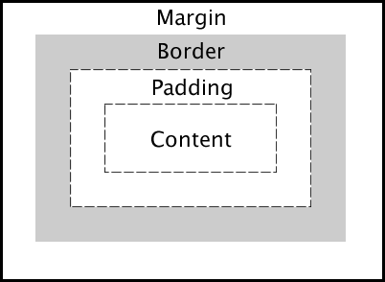

Figure 3: CSS Box Model

**4.3 Web design Techniques**

These are some of the steps I learnt to design any website-

1. Define your project**-** Start off by defining the goal of your project. Also define the audience.

2. Plan out everything- Once the project is defined, plan its content carefully. This includes text, images, videos, icons, etc. Define the navigation. Define the site structure.

3. Sketch the ideas before designing- Now it's time to get inspired and think about your design. One should sketch the ideas before starting to design.

4. Design and develop the website- After sketching, start to design your website using all the guidelines and tips.

5. Optimization- Optimize the website’s performance in terms of site speed. One also need to do some basic search engine optimization (SEO) for search engines such as google.

6. Launch the masterpiece- The optimized website is now finally ready to launch. All needed for launching is a webserver that will host the website and deliver it to the world.

7. Site maintenance- The launch of your website is not the end of the story. Now it's time to monitor the users' behavior and make some changes to the website if necessary.

**4.3.1 Responsive Web design**

Responsive Web Design is about using HTML and CSS to automatically resize, hide, shrink, or enlarge, a website, to make it look good on all devices (desktops, tablets, and phones)

It is the practice of building a website suitable to work on every device and every screen size, no matter how large or small, mobile or desktop.

Responsive web design is broken down into three main components, including flexible layouts, media queries, and flexible media. The first part, flexible layouts, is the practice of building the layout of a website with a flexible grid, capable of dynamically resizing to any width. Flexible grids are built using relative length units, most commonly percentages or em units. These relative lengths are then used to declare common grid property values such as width, margin, or padding.

## Media Queries

In addition to resize text and images, it is also common to use media queries in responsive web pages.

With media queries you can define completely different styles for different browser sizes.

Example:

@media screen and (max-width: 800px) {

. left, main, right {

width: 100%;

}

}

**4.3.2 Browser Dev Tools**

Users will ultimately be interfacing with your websites through a web browser. The way your site is rendered by these browsers is going to be a big part of whether your work is successful or not. All modern web browsers come equipped with developer tools. Specifics will vary from browser to browser, but browser developer tools generally consist of an inspector and a JavaScript console. The inspector allows you to see what the runtime HTML on your page looks like, what CSS is associated with each element on the page, and also allows you to edit your HTML and CSS and see the changes live as they happen. The JS console allows you to view any errors that occur as the browser tries to execute your JS code.

**4.4 Software Development Activities**

A software development process is a structure imposed on the development of a software product. There are several models for such processes, each describing approaches to a variety of tasks or activities that take place during the process. There are different software development models,

1. Waterfall Model

2. Spiral Model

3. Iterative and Incremental Model

4. Agile Model

Amongst these models, my department in Aricent followed agile model in their product development phases. Among the different Agile methods, Scrum method was mostly used.

**4.4.1 SCRUM**

Scrum is an agile way to manage project, usually software development. Agile software development with scrum is often perceived as a methodology, but rather than viewing scrum as methodology, think to it as a framework for managing a process.



Figure 4: Scrum Model

In a scrum process, it has several roles and the relationship among these roles is easily defined and very clear cut and simple. The main roles are-

* Scrum Master
* Product Owner
* Development Team
* QA Team
* Project Manager

In scrum, on each day of a sprint, the team holds a daily scrum meeting called the "daily scrum.” Meetings are typically held in the same location and at the same time each day. Ideally, a daily scrum meeting is held in the morning before starting work, as it helps set the context for the coming day's work. These scrum meetings are strictly time-boxed to 15 minutes. This keeps the discussion brisk but relevant. Team members give update their work and discuss about the problem if anyone face. It’s a good way for a Scrum Master to track the progress of the Team.

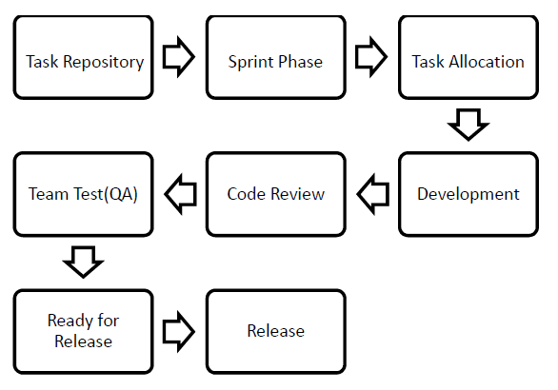

Figure 5: Data Flow of Scrum Model

**4.5 JavaScript**

JavaScript is the programming language of HTML and the Web. JavaScript is easy to learn.It is a language which is also characterized as [dynamic](https://en.wikipedia.org/wiki/Dynamic_programming_language), [weakly typed](https://en.wikipedia.org/wiki/Weak_typing), [prototype-based](https://en.wikipedia.org/wiki/Prototype-based_programming) and [multi-paradigm](https://en.wikipedia.org/wiki/Multi-paradigm_programming_language). JavaScript enables interactive [web pages](https://en.wikipedia.org/wiki/Web_page) and thus is an essential part of [web applications](https://en.wikipedia.org/wiki/Web_application). The vast majority of [websites](https://en.wikipedia.org/wiki/Website) use it,  and all major [web browsers](https://en.wikipedia.org/wiki/Web_browser) have a dedicated [JavaScript engine](https://en.wikipedia.org/wiki/JavaScript_engine) to execute it.

It has an [API](https://en.wikipedia.org/wiki/Application_programming_interface) for working with text, [arrays](https://en.wikipedia.org/wiki/Array_data_type), dates, [regular expressions](https://en.wikipedia.org/wiki/Regular_expression), and basic manipulation of the [DOM](https://en.wikipedia.org/wiki/Document_Object_Model), but the language itself does not include any [I/O](https://en.wikipedia.org/wiki/Input/output), such as networking, storage, or graphics facilities, relying for these upon the host environment in which it is embedded.

**4.5.1 jQuery**

jQuery is a JavaScript Library. It greatly simplifies JavaScript programming. It is a lightweight, "write less, do more", JavaScript library. The purpose of jQuery is to make it much easier to use JavaScript on your website.

jQuery takes a lot of common tasks that require many lines of JavaScript code to accomplish, and wraps them into methods that you can call with a single line of code. There are lots of other JavaScript frameworks out there, but jQuery seems to be the most popular, and also the most extendable.

**4.5.2 Bootstrap**

Bootstrap is a [free and open-source](https://en.wikipedia.org/wiki/Free_and_open-source_software) [framework](https://en.wikipedia.org/wiki/Application_framework) used for designing [websites](https://en.wikipedia.org/wiki/Website) and [web applications](https://en.wikipedia.org/wiki/Web_application). It contains [HTML](https://en.wikipedia.org/wiki/HTML)- and [CSS](https://en.wikipedia.org/wiki/CSS)-based design templates for [typography](https://en.wikipedia.org/wiki/Typography), forms, buttons, navigation and other interface components.

Bootstrap is modular and consists of a series of [Less stylesheets](https://en.wikipedia.org/wiki/Less_(stylesheet_language)) that implement the various components of the toolkit. These stylesheets are generally compiled into a bundle and included in web pages, but individual components can be included or removed.

### Stylesheets

Bootstrap provides a set of stylesheets that provide basic style definitions for all key HTML components. These provide a uniform, modern appearance for formatting text, tables and form elements.

### Re-usable components

In addition to the regular HTML elements, Bootstrap contains other commonly used interface elements. The components are implemented as CSS classes, which must be applied to certain HTML elements in a page.

### JavaScript components

Bootstrap comes with several JavaScript components in the form of [jQuery](https://en.wikipedia.org/wiki/JQuery) plugins. They provide additional user interface elements such as dialog boxes, tooltips, and carousels

**4.6 Angular**

Angular is a platform that makes it easy to build applications with the web. Angular combines declarative templates, dependency injection, end to end tooling, and integrated best practices to solve development challenges. Angular empowers developers to build applications that live on the web, mobile, or the desktop. It is a [TypeScript](https://en.wikipedia.org/wiki/TypeScript)-based [open-source](https://en.wikipedia.org/wiki/Open-source_software) front-end [web application platform](https://en.wikipedia.org/wiki/Web_framework) led by the Angular Team at [Google](https://en.wikipedia.org/wiki/Google) and by a community of individuals and corporations. Angular is a complete rewrite from the same team that built [AngularJS](https://en.wikipedia.org/wiki/AngularJS).

**4.6.1 Architecture overview**

The basic building blocks of an Angular application are *NgModules*, which provide a compilation context for components. NgModules collect related code into functional sets; an Angular app is defined by a set of NgModules. An app always has at least a root module that enables bootstrapping, and typically has many more feature modules.

Like JavaScript modules, NgModules can import functionality from other NgModules, and allow their own functionality to be exported and used by other NgModules. For example, to use the router service in your app, you import the [Router](https://angular.io/api/router/Router) NgModule.

**4.6.2 Components**

Every Angular application has at least one component, the *root component* that connects a component hierarchy with the page document object model (DOM). Each component defines a class that contains application data and logic, and is associated with an HTML *template* that defines a view to be displayed in a target environment. The @Component () decorator identifies the class immediately below it as a component, and provides the template and related component-specific metadata.

**4.6.3 Routing**

The Angular Router NgModule provides a service that lets you define a navigation path among the different application states and view hierarchies in your app. It is modeled on the familiar browser navigation conventions:

* Enter a URL in the address bar and the browser navigates to a corresponding page.
* Click links on the page and the browser navigates to a new page.
* Click the browser's back and forward buttons and the browser navigates backward and forward through the history of pages you've seen.

The router maps URL-like paths to views instead of pages. When a user performs an action, such as clicking a link, that would load a new page in the browser, the router intercepts the browser's behavior, and shows or hides view hierarchies.

**4.6.4 Pipes**

Angular pipes are a way to write display-value transformations that you can declare in your HTML.

**4.7 Node js and Npm**

Node.js is an open source server environment. It allows you to run JavaScript on the server. It is free and runs on various platforms (Windows, Linux, Unix, Mac OS X, etc.) It uses JavaScript on the server. Node.js uses asynchronous programming. A common task for a web server can be to open a file on the server and return the content to the client. Node.js file request handling:

1. Sends the task to the computer's file system.
2. Ready to handle the next request.
3. When the file system has opened and read the file, the server returns the content to the client.

NPM (Node Package Manager) is the default package manager for Node.js and is written entirely in [JavaScript](https://www.geeksforgeeks.org/javascript-tutorial/). NPM manages all the packages and modules for Node.js and consists of command line client npm. It gets installed into the system with installation of Node.js. The required packages and modules in Node project are installed using NPM.

A package contains all the files needed for a module and modules are the JavaScript libraries that can be included in Node project according to the requirement of the project.

**4.8 Google Maps Integration**

[Angular Google Maps](https://angular-ui.github.io/angular-google-maps/#!/) is a set of directives that integrate Google Maps in an AngularJS application. It makes using Google Maps in such an application very easy as you don’t need to know the Google Maps API in order to use it.

Google Maps allows you to attach events to your map, your markers, and basically anything you add to your map. For instance, the above example features a “dragend” event attached to a marker. You can grab the marker and drag it around to see what the event does. Markers and maps use their default Google Maps styling unless you specify a custom look & feel. [This tool](http://gmaps-samples-v3.googlecode.com/svn/trunk/styledmaps/wizard/index.html) allows you to define your own style and then outputs a JSON config that you can use in your own map. I used it to create this example in less than five minutes. I changed most of the colors of the map and removed city labels.

**4.8.1 Localization**

You can localize your Maps JavaScript API application by changing the default language settings and by specifying a region code, which alters the map's behavior based on a given country or territory.

**4.8.2 Versioning**

The Maps JavaScript API team regularly updates the API with new features, bug fixes, and performance improvements. You can indicate which version of the API to load within your application by specifying it in the vparameter of the Maps JavaScript API bootstrap request.

**4.8.3 Basic Map Types**

There are four types of maps available within the Maps JavaScript API. The following map types are available in the Maps JavaScript API:

* roadmap displays the default road map view.
* satellite displays Google Earth satellite images.
* hybrid displays a mixture of normal and satellite views.
* terrain displays a physical map based on terrain information.

# **4.8.4 Layers**

Layers are objects on the map that consist of one or more separate items, but are manipulated as a single unit. Layers generally reflect collections of objects that you add on top of the map to designate a common association. The Maps JavaScript API manages the presentation of objects within layers by rendering their constituent items into one object (typically a tile overlay) and displaying them as the map's viewport changes. Layers may also alter the presentation layer of the map itself, slightly altering the base tiles in a fashion consistent with the layer.

**Chapter 5**

**APPLICATION IN TRAINING**

Here is the demonstration/prototype of the two projects I undertook during my internship:

**5.1 Startup Company Website Homepage**

For the first two weeks in the company for my internship, I learnt about HTML, CSS and JavaScript and was told to implement it in as a small project. I had to design a homepage for a startup company which looks visually appealing and original to the idea. So, I created a startup that is basically an on-call valet services for people which can be called through an app or a website to help people park their cars. They can later retain their cars using the website/ app also. The whole HTML code is present is appendix. Some of the screenshots of the website are:

This is the front view of the homepage with two buttons with hover properties and a fixed background image.

It is done through this CSS-

header {

background-image: linear-gradient (rgba (0, 0, 0, 0.6), rgba (0, 0, 0, 0.6)), url("img/background.jpg");

background-size: cover;

background-position: center;

height: 100vh;

background-attachment: fixed;

}

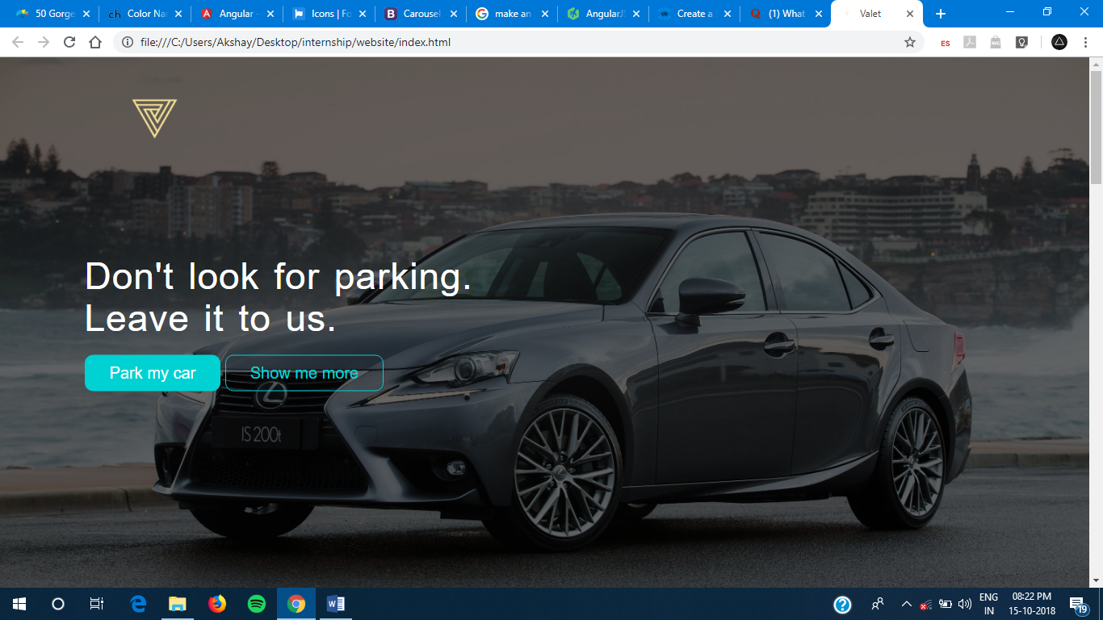

Figure 6: Starting view of website

On clicking the “Show Me More” button the website automatically scrolls down to the next section.

This includes use of icons and sections to describe random text which looks appealing using grid in Bootstrap.

This grid code in done in HTML-

<div class="row">

<div class="col span-1-of-4 box">

<i class="icon ion-md-car icon"></i>

<h3> ABC </h3>

<p>Yourself off its pleasant ecstatic now law. </p>

</div>

<div class="col span-1-of-4 box">

<i class="icon ion-md-cart icon"></i>

<h3> DEF </h3>

<p> Considered introduced themselves mr to discretion at. </p>

</div>

<div class="col span-1-of-4 box">

<i class="icon ion-md-card icon"></i>

<h3> GHI </h3>

<p> Giving cousin warmly things no spring mr be abroad. <p>

</div>

<div class="col span-1-of-4 box">

<i class="icon ion-md-alert icon"></i>

<h3> JKL </h3>

<p> By in entirely securing suitable graceful at families. </p>

</div>

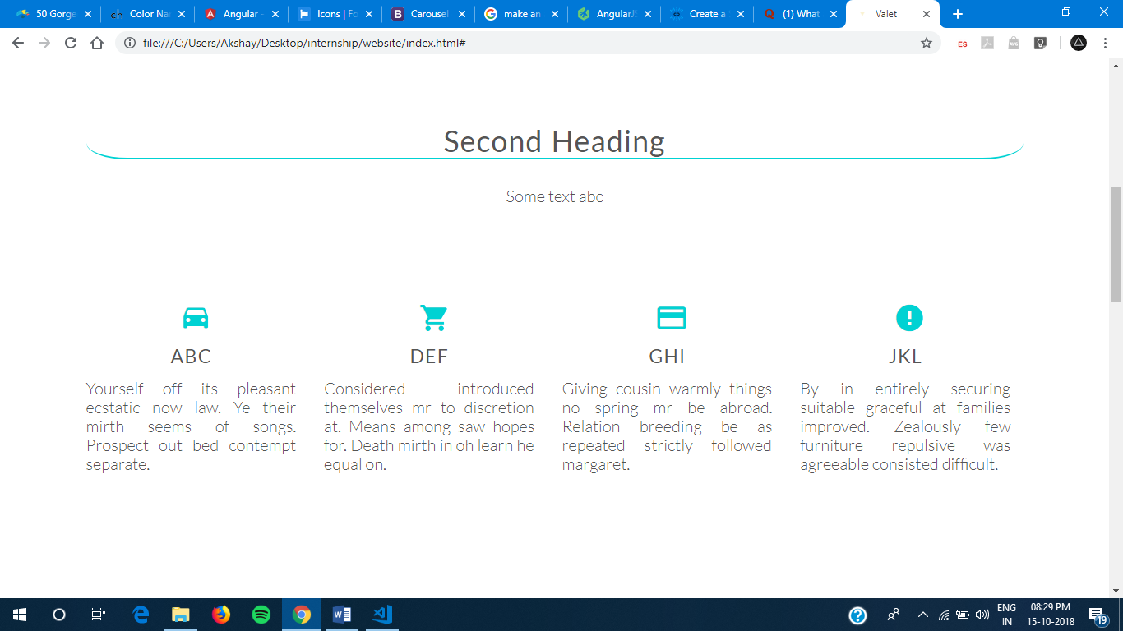

Figure 7: Section using grid

Next comes a step method with normal links and the section in divided in two sections: One is the section with a photo and other with 3 steps with 2 links at the bottom.

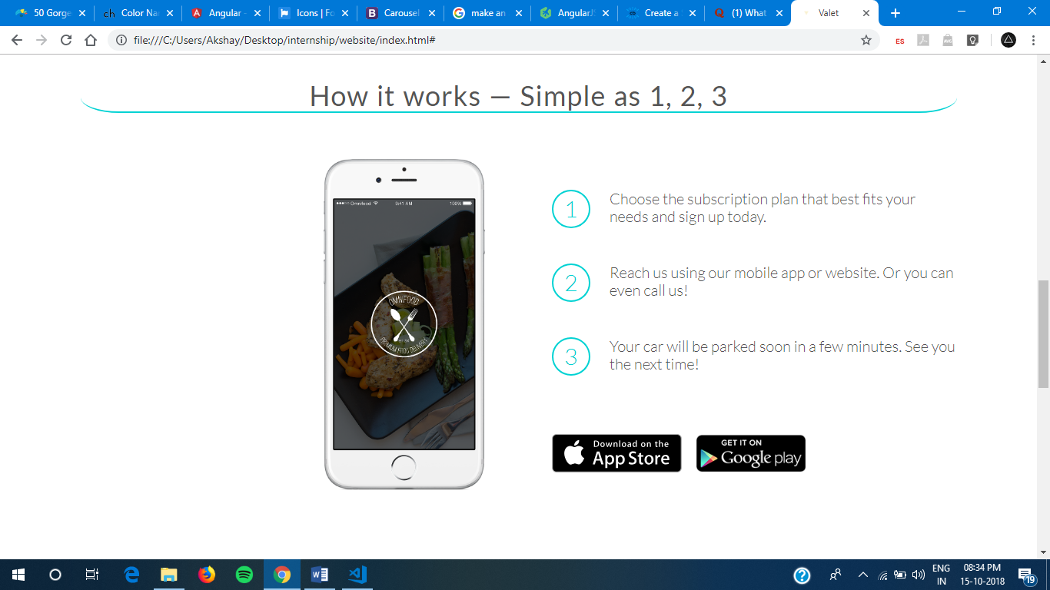

Figure 8: A simple step method with two grid section

The Button on top saying “Park my Car” send us to this section which shows prices along with deals and packages of this company. This is done using the JavaScript classes as well as bootstrap-

<div class="row">

<div class="col span-1-of-3">

<div class="plan-box js--wp-4">

<div>

<h3>Premium</h3>

<p class="plan-price">$99 <span>/ month</span></p>

<p class="plan-price-meal">That's only 3.30$ per park</p>

</div>

<div>

<ul>

<li>1 park every day</li>

<li>Order 24/7</li>

<li>Access to newest creations</li>

<li>Free delivery</li>

</ul>

</div>

<div>

<a href="#" class="btn btn-full">Sign up now</a>

</div>

</div>

</div>

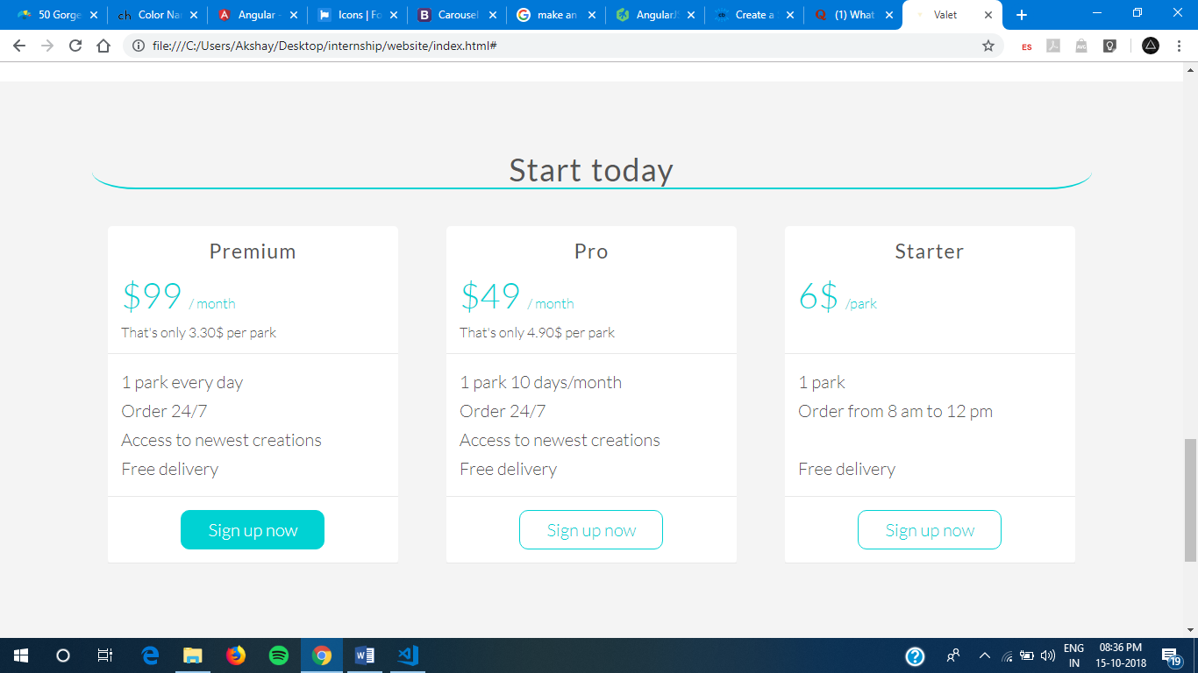

Figure 9: Packages description of the website.

The rest is just a normal footer for the website for which the code is in the Appendix.

**5.2 Google Map Integration Using Angular**

In the next two weeks I learnt about angular and how it connects all the HTML, CSS, scripts etc. with components. Then I started to learn about google-map integration using angular because of a project my assigned department was working on. They had to make a map integration in the shopping cart of the IKEA website and wanted the ability for user to view all the stores nearby using maps. I tried to replicate this map integration but with different array of my own and add layers to maps.

The google maps were installed using npm and using an API key from Google Maps which they provide free for 12 months.

This code was enough to make the maps load-

GoogleMapsLoader.KEY = "***************************************";

GoogleMapsLoader.LIBRARIES = ['geometry', 'places'];

GoogleMapsLoader.VERSION = "3.14";

GoogleMapsLoader.LANGUAGE = 'en';

GoogleMapsLoader.load(google => {

this.map = new google.maps.Map(this.GoogleMap.nativeElement, mapProp); }

The array of all the places looks something like this-

staticHeros = [

{id: 1, name: 'Delhi', lat: 28.6139, lng: 77.2090, desc: 'Capital of India’},

{id: 2, name: 'Mumbai', lat: 19.0760, lng: 72.8777, desc: 'City in India’},

{id: 3, name: 'Moscow', lat: 55.75, lng: 37.62, desc: 'Capital of Russia’},

{id: 4, name: 'Tokyo ', lat: 35.6895, lng: 139.6917, desc: 'Capital of Japan’},

{id: 5, name: 'New York', lat: 40.7128, lng: -74.0060, desc: 'City in USA’},

{id: 6, name: 'London', lat: 51.5074, lng: -0.1278, desc: 'Capital of England’},

{id: 7, name: 'Singapore ', lat: 1.3521, lng: 103.8598, desc: 'Capital of Singapore’},

{id: 8, name: 'Los Angeles', lat: 34.0522, lng: -118.2437, desc: 'City in USA’},

{id: 9, name: 'Cape Town', lat: -33.9249, lng: 18.4241, desc: 'Capital of South Africa’},

{id: 10, name: 'Madrid', lat: 40.4168, lng: -3.7038, desc: 'Capital of Spain’}

]; Now here are some of the outputs of my designed angular website-

This is a basic dashboard with have various components like a navbar at the top and then a few buttons of top places. Along with it there is a search bar to search through the designed array of places along with their description, latitude and longitude.

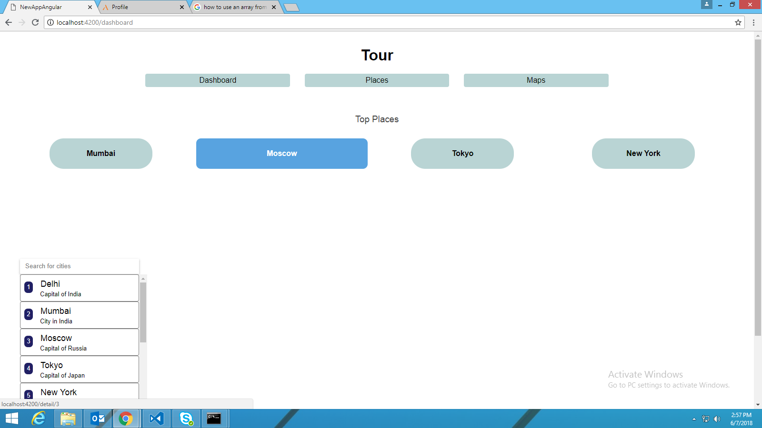Figure 10: Dashboard of Angular website

Then I used routing to making the button of the places or the places getting on search bar to open this details page which uses NgModel to edit the places name and save them which is reflected all over the website. We can also view other details of that place like id, desc, latitude and longitude. The NgModel is implemented in this way-

<label>name:

<input [(ngModel)] ="hero.name" placeholder="name"/>

</label>

The routing takes places in this way-

if (this. href == "/maps") {

this.description.emit(place);

}

else if (this.href == "/dashboard") {

var myurl = `/detail/${place.id}`;

this.router.navigateByUrl(myurl);

}

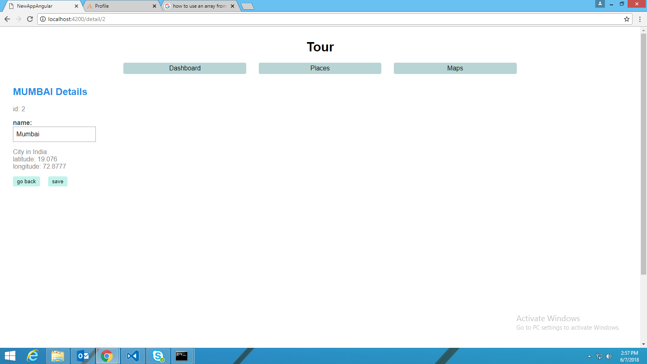

Figure 11: Details page of any place

One can also view all the places in the array, add any other place and delete any as required.

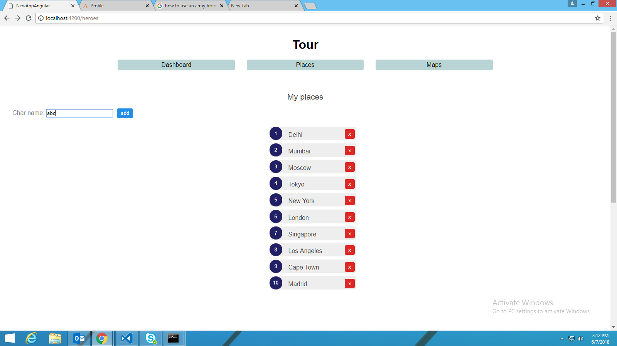

Figure 12: List showing all the places

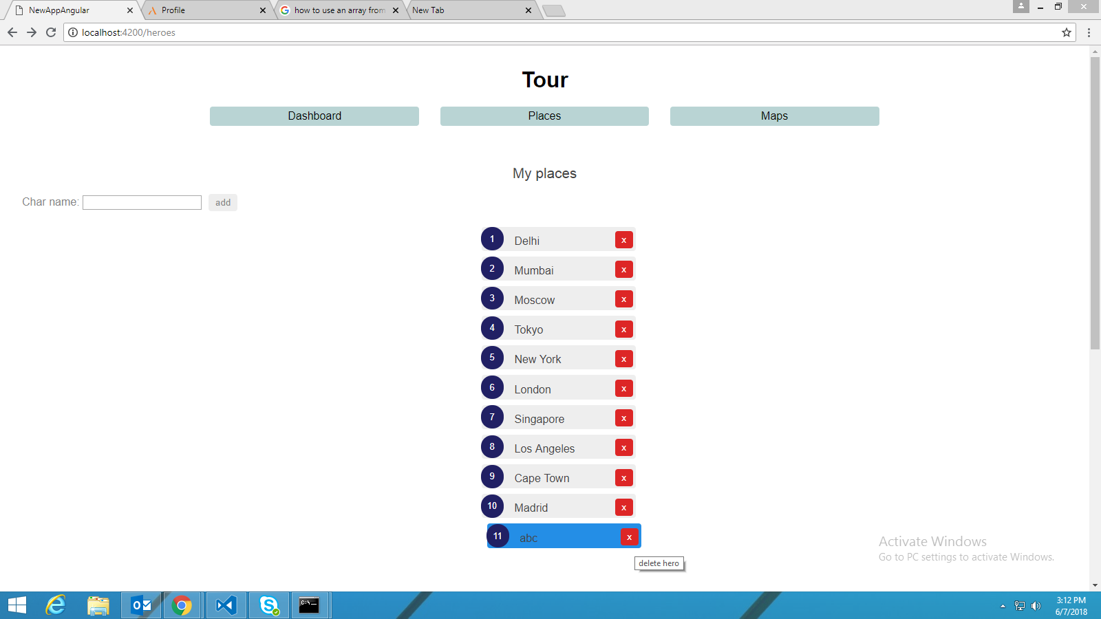

Figure 13: Ability to add or delete places

The next tab was for the map section which showed all these places in the map. The map begins at your own location pinpointing it.

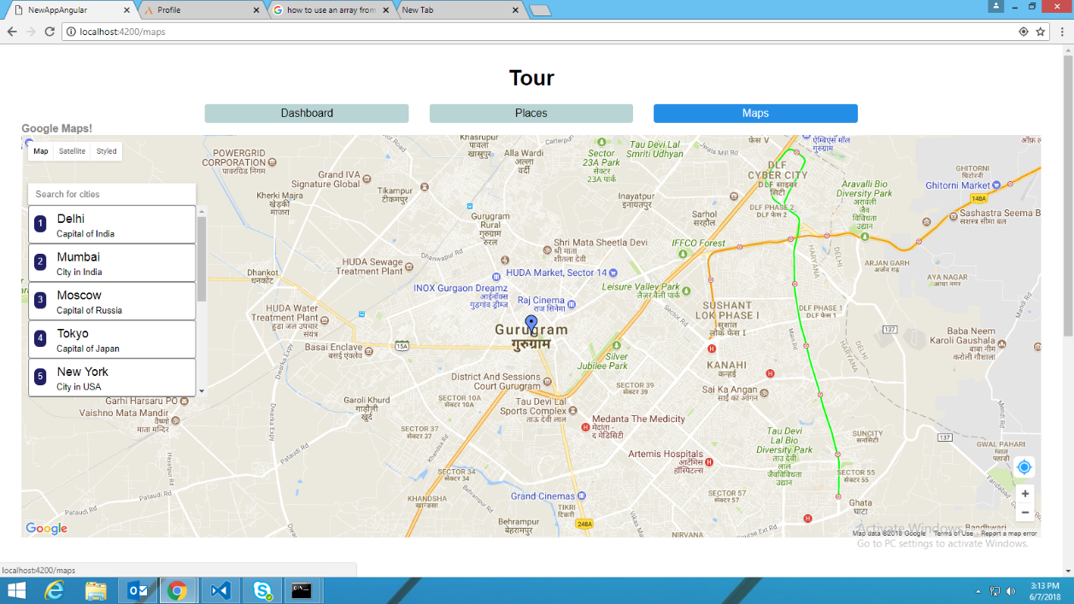

Figure 14: Map Integrated in Angular

There is also a search bar on this map which is the same bar which was visible at the dashboard. This is a feature of Angular which helps us reuse the components. In Maps tab, on searching in this bar one can view the city search along with its details.

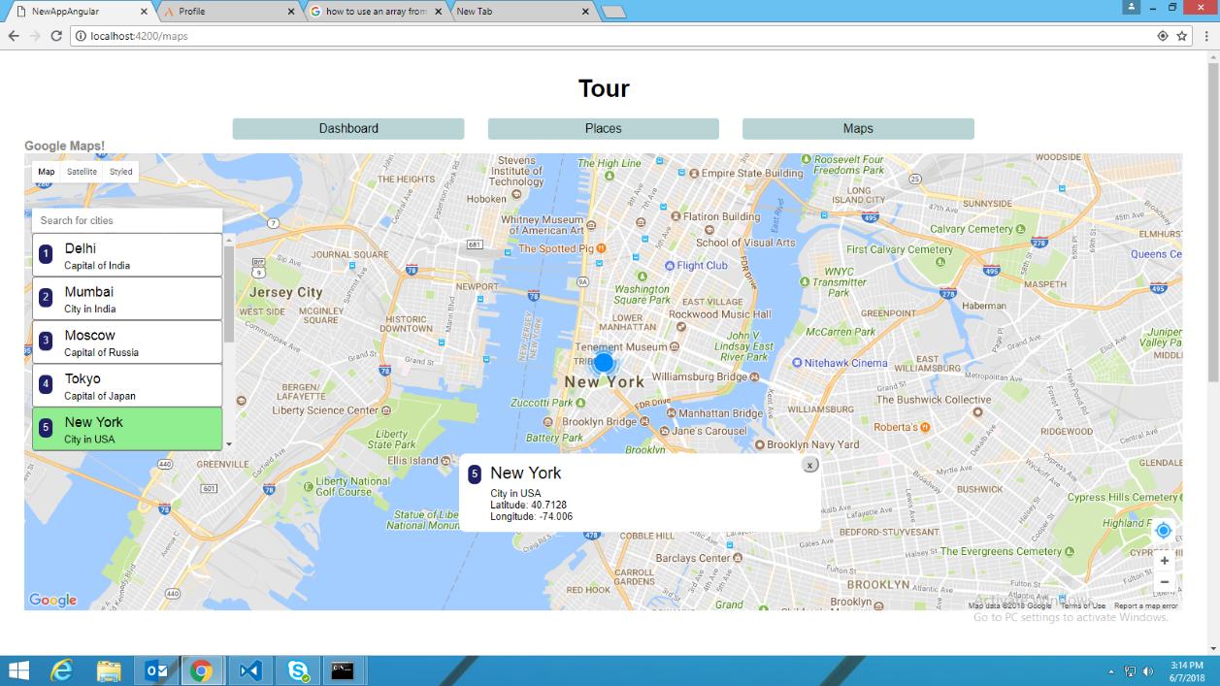

Figure 15: Place Search in maps

**Chapter 6**

**Self-Evaluation**

**6.1 Evaluating Myself**

This internship period has given so many effects on my career goals. This Internship in Aricent was a great experience for me. It opens up many new opportunities for me to have career in this field. I did learn many things, such as the knowledge, skills and attitude.

I know what I should do and I do what is my job desk and also help other coworker whom needed help. I have improving my skills of communication and also improved my programming skills.

Attitude is also an important point. The attitudes needed in the workplace are such as courteous, punctual, discipline, respectful, professional and work faster and efficiently.

I have learned to adjust myself to different personalities of people.

I learn to work faster and efficiently.

I learn to hide my personal feelings into my job. For example, I have to be professional even I am not in the good mood, I have to work in high performance and keep the smile up

I think this internship program was worth enough because the students have not just gotten real work experiences, they also have learned many new skills, get more connections and business ‘knowledge. This internship helped me to gain better understanding about the theory they learned in the university. They could implement the theory when they start working

**6.2 Internship Benefits**

Internship can benefit everyone involved including industry employer, student interns, educational institutions and community.

For the student interns, internships provide an opportunity to explore career opportunities with potential “full-time” employers, learn new skills, gain needed work experience for professional certifications, begin to develop a network of professional colleagues, enhance their professional resume, and pursue their future dreams.

In details, students gain a head start in their career fields and sometimes secure full-time employment with their internship site upon graduation; as a result of participation, student may earn money to support their college expenses; student gain real-world experience, often learning about the latest technology and equipment used in the workplace; students may develop business contacts.

These people can help to find a job later on, act as references; students have the opportunity to develop social relationships and skills; students learn job-seeking and job-holding skills, and, as a result, gain maturity, professionalism, and confidence; students often gain new perspective because students are able to see the application and relevance of what they are learning; students have opportunities to sample their chosen career fields early in their studies.

For many students, the internship experience contributes to a greater sense of responsibility for their own efforts and greater dependence on their own judgment.

**6.3 Conclusion**

In a nutshell, this internship has been an excellent and rewarding experience. I can

conclude that there have been a lot I’ve learnt from my work.

Needless to say, the technical aspects of the work I’ve done are not flawless and

could be improved provided enough time.

As someone with no prior experience in JavaScript and Angular whatsoever I believe my time spent in coding and discovering new languages was well worth it and contributed to finding an acceptable solution to an important aspect of web design and development.

Two main things that I’ve learned the importance of, are time-management skills and self-motivation. Although I have often stumbled upon these problems at University, they had to be approached differently in a working environment.

Working with web development languages has increased my interest in them and finally I want to thank VIT University for providing this opportunity of Industrial Internship as a Mandatory Course in our Curriculum.

**APPENDIX-1**

**Startup Website HTML Code-**

<!DOCTYPE html>

<html lang="en">

    <head>

        <link rel="stylesheet" type="text/css" href="vendors\css\grid.css">

        <link rel="stylesheet" type="text/css" href="Resources\css\styles.css">

        <title>Valet</title>

    </head>

    <body>

        <header>

            <nav>

                <div class="row">

                    <img src="Resources\img\Logo.png" alt="Logo" class="logo">

                </div>

            </nav>

            <div class="hero-text-box">

                <h1>Don't look for parking.<br>Leave it to us.</h1>

                <a class="btn btn-full js--scroll-to-plans" href="#">Park my car</a>

                <a class="btn btn-ghost js--scroll-to-start" href="#">Show me more</a>

            </div>

        </header>

        <section class="section-features js--section-features">

            <div class="row">

            <h2>Second Heading</h2>

            <p class="long-text">

            Some text abc

            </p>

            </div>

            <div class="row">

                <div class="col span-1-of-4 box">

                    <i class="icon ion-md-car icon"></i>

                    <h3> ABC </h3>

                    <p>Yourself off its pleasant ecstatic now </p>

                </div>

                <div class="col span-1-of-4 box">

                    <i class="icon ion-md-cart icon"></i>

                    <h3> DEF </h3>

                    <p> Considered introduced themselves mr to </p>

                </div>

                <div class="col span-1-of-4 box">

                    <i class="icon ion-md-card icon"></i>

                    <h3> GHI </h3>

                    <p> Giving cousin warmly things no spring.</p>

                </div>

                <div class="col span-1-of-4 box">

                    <i class="icon ion-md-alert icon"></i>

                    <h3> JKL </h3>

                    <p> By in entirely securing suitable graceful </p>

                </div>

            </div>

        </section>

        <section class="section-steps">

            <div class="row">

                <h2>How it works &mdash; Simple as 1, 2, 3 </h2>

            </div>

            <div class="row">

                <div class="col span-1-of-2 steps-box">

                    <img src="Resources/img/app-iPhone.png" alt="app on iPhone" class="app js--wp-2">

                </div>

                <div class="col span-1-of-2 steps-box">

                    <div class="works-step">

                        <div>1</div>

                        <p>Choose the subscription plan p>

                    </div>

                    <div class="works-step">

                        <div>2</div>

                        <p>Reach us using our mobile app or website</p>

                    </div>

                    <div class="works-step">

                        <div>3</div>

                        <p>Your car will be parked soon in a few minutes</p>

                    </div>

                    <a href="#" class="btn-app"><img src="Resources/img/download-app.svg" alt="App Store Button"></a>

                    <a href="#" class="btn-app"><img src="Resources/img/download-app-android.png" alt="Play Store Button"></a>

                </div>

            </div>

        </section>

        <section class="section-plans js--section-plans">

            <div class="row">

                <h2>Start today</h2>

            </div>

            <div class="row">

                <div class="col span-1-of-3">

                    <div class="plan-box js--wp-4">

                        <div>

                            <h3>Premium</h3>

                                <p class="plan-price">$99 <span>/ month</span></p>

                                <p class="plan-price-meal">That's only 3.30$ per park</p>

                        </div>

                        <div>

                            <ul>

                                <li>1 park every day</li>

                                <li>Order 24/7</li>

                                <li>Access to newest creations</li>

                                <li>Free delivery</li>

                            </ul>

                        </div>

                        <div>

                            <a href="#" class="btn btn-full">Sign up now</a>

                        </div> </div></div>

                <div class="col span-1-of-3">

                    <div class="plan-box">

                        <div>

                            <h3>Pro</h3>

                            <p class="plan-price">$49 <span>/ month</span></p>

                            <p class="plan-price-meal">That's only 4.90$ per park</p>

                        </div>

                        <div>

                            <ul>

                                <li>1 park 10 days/month</li>

                                <li>Order 24/7</li>

                                <li>Access to newest creations</li>

                                <li>Free delivery</li>

                            </ul>

                        </div>

                        <div>

                            <a href="#" class="btn btn-ghost">Sign up now</a>

                        </div>

                    </div>

                </div>

                <div class="col span-1-of-3">

                    <div class="plan-box">

                        <div>

                            <h3>Starter</h3>

                            <p class="plan-price">6$ <span>/park</span></p>

                            <p class="plan-price-meal">&nbsp;</p>

                        </div>

                        <div>

                            <ul>

                                <li>1 park</li>

                                <li>Order from 8 am to 12 pm</li>

                                <li>&nbsp;</li>

                                <li>Free delivery</li>

                            </ul>

                        </div>

                        <div>

                            <a href="#" class="btn btn-ghost">Sign up now</a>

                        </div>

                    </div>

                </div>

            </div>

        </section>

        <footer>

            <div class="row">

                <div class="col span-1-of-2">

                    <ul class="footer-nav">

                        <li><a href="#">About us</a></li>

                        <li><a href="#">Blog</a></li>

                        <li><a href="#">Press</a></li>

                        <li><a href="#">iOS App</a></li>

                        <li><a href="#">Android App</a></li>

                    </ul>

                </div>

                <div class="col span-1-of-2">

                <ul class="social-links" >

                    <li><a href="#"><i class="icon ion-logo-facebook"></i></a></li>

                    <li><a href="#"><i class="icon ion-logo-twitter"></i></a></li>

                    <li><a href="#"><i class="icon ion-logo-googleplus"></i></a></li>

                    <li><a href="#"><i class="icon ion-logo-instagram"></i></a></li>

                </ul>

                </div>

            </div>

            </div>

        </footer>

        <script src="https://ajax.googleapis.com/ajax/libs/jquery/3.3.1/jquery.min.js"></script>

        <script src="Resources/js/script.js"></script>

    </body>

</html>

**APPENDIX-2**

**Map Integration in Angular Code-**

**App Component HTML**

<h1>{{title}}</h1>

<nav>

<a routerLink="/dashboard" title="Dashboard">Dashboard</a>

<a routerLink="/heroes"title="Places">Places</a>

<a routerLink="/maps"title="Maps">Maps</a>

</nav>

<router-outlet></router-outlet>

<app-messages></app-messages>

**Place Detail HTML**

<div *ngIf="hero">

<h2>{{ hero.name | uppercase }} Details</h2>

<div><span>id: </span>{{hero.id}}</div>

<div>

<label>name:

<input [(ngModel)]="hero.name" placeholder="name"/>

</label>

</div>

<div>{{hero.desc}}</div>

<div><span>latitude: </span>{{hero.lat}}</div>

<div><span>longitude: </span>{{hero.lng}}</div>

<button (click)="goBack()">go back</button>

<button (click)="save()">save</button>

</div>

**Place Detail TS-**

export class HeroDetailComponent implements OnInit {

@Input() hero: Hero;

constructor(

private route: ActivatedRoute,

private heroService: HeroService,

private location: Location

) {}

ngOnInit(): void {

this.getHero();

}

getHero(): void {

const id = +this.route.snapshot.paramMap.get('id');

this.heroService.getHero(id)

.subscribe(hero => this.hero = hero);

}

goBack(): void {

this.location.back();

}

save(): void {

this.heroService.updateHero(this.hero)

.subscribe(() => this.goBack());

}

}

**Search Bar HTML**

<input #searchBox id="search-box" [(ngModel)]="searchText" placeholder="Search for cities" (click)="showlist($event)" (keydown)="showlist($event)"/>

<ul class="search-result">

<li id="demo{{i}}" title="{{hero.name}}" *ngFor="let hero of staticHeros| FilterPipe: searchText; let i = index">

<a (click)="descriptionTest(hero, i)" (mouseenter)="descriptionChange(hero)" >

<span class="placeid">{{hero.id}}</span> {{hero.name}}

<div class="placedesc"> {{hero.desc}} </div>

</a>

</li>

</ul>

**Search Bar TS**

export class MapSearchComponent implements OnInit {

id: any;

varid = 1;

public href: string = "";

constructor(private heroService: HeroService,

private router: Router) { }

}

ngOnInit(): void {

this.href = this.router.url;

}

public descriptionTest(place: any, i): void {

document.getElementById("demo" + this.varid).style.backgroundColor = "white";

this.varid = i;

document.getElementById("demo" + i).style.backgroundColor = "lightgreen";

if (this.href == "/maps") {

this.description.emit(place);

}

else if (this.href == "/dashboard") {

var myurl = `/detail/${place.id}`;

this.router.navigateByUrl(myurl);

}

}

public descriptionChange(place2: any): void {

if (this.href == "/maps") {

this.description2.emit(place2);

}

}

public descriptionOriginal(): void {

if (this.href == "/maps") {

this.description3.emit();

}

}

public showlist(event): void {

setTimeout(function () {

for (var i = 0; i < 100; i++) {

if (document.getElementById("demo" + i)) {

document.getElementById("demo" + i).style.display = "block";

} } }, 100); }}

**Google Maps TS**

export class GoogleMapsComponent implements OnInit {

@ViewChild('GoogleMap') GoogleMap;

private searchTerms = new Subject<string>();

boxLat3: number;

boxLng3: number;

search(term: string): void {

this.searchTerms.next(term);

}

ngOnInit(): void {

this.showmylocation();

}

showPosition(position) {

var lat = position.coords.latitude;

var lng = position.coords.longitude;

this.boxLat = lat;

this.boxLng = lng;

if(this.flag2==0)

{

this.flag2=1;

this.setMap();

}

else{

var mylat = this.map.getCenter().lat();

if (mylat != this.boxLat) {

var center = new google.maps.LatLng(this.boxLat, this.boxLng);

this.map.panTo(center);

this.map.setZoom(13);

} } }

setMap() {

var myLatLng = { lat: this.boxLat2 || this.boxLat, lng: this.boxLng2 || this.boxLng };

var mapProp = {

zoomControl: true,

mapTypeControl: true,

center: myLatLng,

zoom: 13,

disableDefaultUI: true,

gestureHandling: "cooperative",

mapTypeControlOptions: {

mapTypeIds: ['roadmap', 'satellite', 'hybrid', 'terrain',

'styled_map'],

}

};

setTimeout(() => {

GoogleMapsLoader.KEY = "*********************";

GoogleMapsLoader.LIBRARIES = ['geometry', 'places'];

GoogleMapsLoader.VERSION = "3.14";

GoogleMapsLoader.LANGUAGE = 'en';

GoogleMapsLoader.load(google => {

this.map = new google.maps.Map(this.GoogleMap.nativeElement, mapProp);

this.map.mapTypes.set('styled_map', styledMapType);

this.map.setMapTypeId('roadmap');

var marker = new google.maps.Marker({

position: { lat: this.boxLat2 || this.boxLat, lng: this.boxLng2 || this.boxLng },

map: this.map,

icon: 'assets/m3.png'

});

description3() {

this.getLocation();

}

handleClick() {

this.showDescritionUI = false;

} } }

**Routing Module TS**

const routes: Routes = [

{ path: '', redirectTo: '/dashboard', pathMatch: 'full' },

{ path: 'dashboard', component: DashboardComponent },

{ path: 'detail/:id', component: HeroDetailComponent },

{ path: 'heroes', component: HeroesComponent },

{ path: 'maps', component: GoogleMapsComponent }

];